CrystalClearEssentials

Crystal Clear Essentials
User Guide

Tami Sauer Steve Stroz
Crystal Clear essentials

Crystal Clear Essentials User Guide
Tami Sauer & Steve Stroz

© 2012 Crystal Clear Essentials. All rights reserved.
Developed for Crystal Clear Essentials version 2
www.crystalclearessentials.com

This document may not be copied, photocopied, or reproduced without prior consent from Crystal Clear Essentials.

Every effort has been made to ensure the accuracy of the contents of this manual; however, Crystal Clear Essentials makes no warranties with respect to this documentation, the contents, or implied warranties. Crystal Clear Essentials shall not be liable for any errors or damages in connection with the contents, performance, or use of this manual. All trademarks are the property of their respective owners.

Introduction

Crystal Clear Essentials is a powerful new reporting tool for your ACT! system!

Built using the world’s most popular report generator, Crystal Reports, Crystal Clear Essentials delivers vital information to managers and executives in a way that is not possible using the built-in ACT! report generator.

These essential reports can easily be run from the ACT! report menu and include prompts allowing the user to further customize the report. Considering all of the flexibility available through user selections, there are thousands of possible reporting outcomes.

Don’t see the report you need? Want to add your company logo or color scheme? Not a problem. Your ACT! certified consultant or the staff at Crystal Clear Essentials can help.

Please direct any comments, suggestions, or questions to your ACT! certified consultant or:

Tami & Steve
requests@crystalclearessentials.com

Table of Contents

Introduction ii
System Requirements 1
Performance 2
Installation 3
CrystalClearRuntimeInstaller.exe 3
CrystalClearEssentialsInstaller.exe 8
File Locations 11
Purchase & Registration 13
Trial Mode 13
Purchasing and Registration 14
If you already have a serial number 19
Uninstalling Crystal Clear Essentials 20
Running Reports 22
Working With Parameters (User Prompts) 25
Filter (All Contacts/Current Lookup) 25
Date Range 25
Record Manager 26
Report Display 26
Activity Type 27
History Type 27
Group Name 28
Opportunity Range 28
The Crystal Clear Essentials Window 29
Crystal Clear Essentials Tool Bar 29
Printing Reports 30
Exporting Reports 31
My Reports Window 32
Adding Reports to the My Reports Window 32
Removing Reports from the My Reports window 33
Repositioning Reports in the My Reports window 33
Saving your changes to the My Reports window 34
Updating Crystal Clear Essentials 34
Contact Reports 35
Company Report 35
Group Reports 36
Opportunity Reports 36
Product Reports 37
Activity Reports 37
History Reports 37
Note Reports 37
Analysis Reports 38
System Reports 38
Installation Trouble, Registration Problems, or Error Messages 39
Crystal Clear Essentials Report Questions 39
Additional Report Requests 39

Chapter
1

Getting Started
Review this section if you have not installed or registered Crystal Clear Essentials.
t
his chapter explains the system requirements and installation and registration procedure for Crystal Clear Essentials.

System Requirements
Each workstation that uses Crystal Clear Essentials version 2 must have an installed copy of ACT! 2010 or greater.



Tip:
Crystal Clear Essentials version 1 works with ACT! 2006, 2007, 2008, or 2009. If the version of ACT! you are using is prior to ACT2006 contact your ACT! certified consultant or the staff at Crystal Clear Essentials. There are reporting alternatives for earlier versions of ACT!

If the performance of your ACT! application is acceptable then your workstation meets the minimum requirements for Crystal Clear Essentials.

At Crystal Clear Essentials we like our reports to run fast so we invest in the best computer possible. You will notice increased performance if you have a fast microprocessor (2 GHz or greater), a lot of RAM (2 GB or greater), and fast hard drives with a lot of free space (10,000 RPM with 10 Gigabytes or greater available).

Performance

There are many variables that will impact the speed with which reports are generated:

The Computer System:
As noted above, your reports will run faster on newer computers with powerful components (processor, RAM, hard drive). Additionally, if your database is located on a different computer, such as a file server, your reports may take longer to generate because of the delay introduced by your network.

The Database:
Crystal Clear Essentials reads through your ACT! database to find the appropriate information. As your database grows the reports will take longer to generate. To optimize database performance remember to remove old records that are no longer needed (like old contacts and history records) and regularly perform database maintenance.



Tip:
Concerned about performance? We recommend that you install the trial version of Crystal Clear Essentials and experiment running the reports so that you can be confident in your purchase.

Installation
There are two installations to complete before you can use Crystal Clear Essentials.

- CrystalClearRuntimeInstaller.exe
- CrystalClearEssentials2Installer.exe

?

Why:
Why have two installations? One installation is for CrystalClear Essentials, one installation is for Crystal Reports run-time files (the files that make the reports run). As updates are introduced we can deliver them to you as smaller files decreasing the time required to download and installation updates – saving you time!

CrystalClearRuntimeInstaller.exe
This installation package installs the Crystal Reports run-time files that are necessary to run Crystal Clear Essentials reports.

Download the CrystalClearRuntimeInstaller.exe file to your computer.
Double-click the CrystalClearRuntimeInstaller.exe to begin installation.

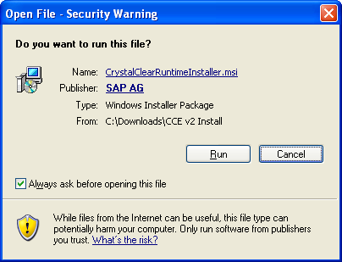

If you receive the following dialog, click the Run button.

Be patient while the installer checks your computer for system requirements…

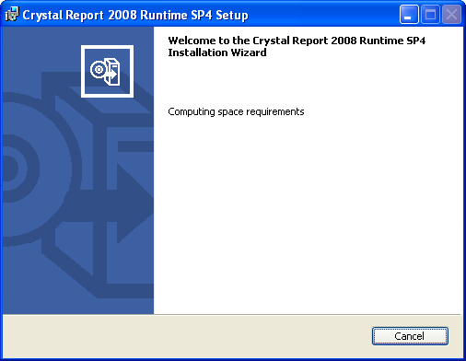

Be patient while the installer checks your computer for system requirements, etc…

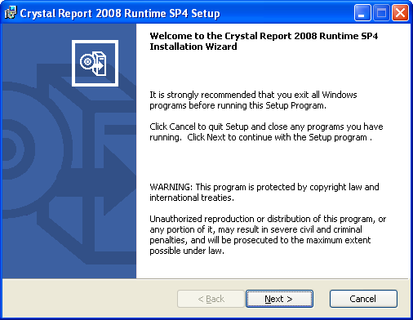

Click Next to continue the installation

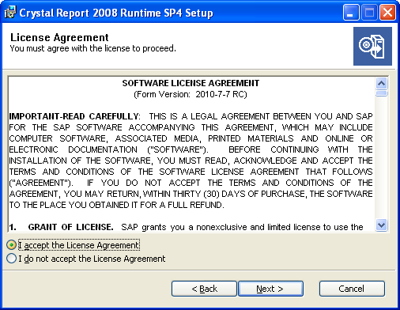

Click the “I accept the license agreement” radio button and Click Next

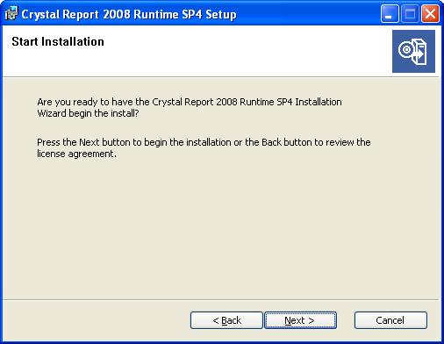

Click Next to continue the installation

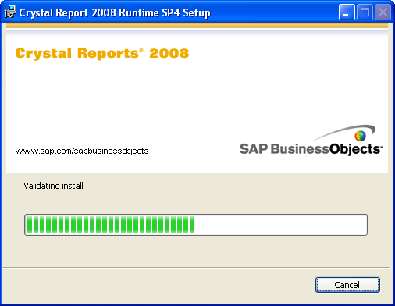

The installation begins…

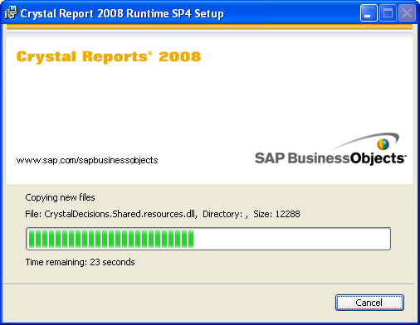

The installer will begin to copy and register files on your computer. This process will take a few minutes.

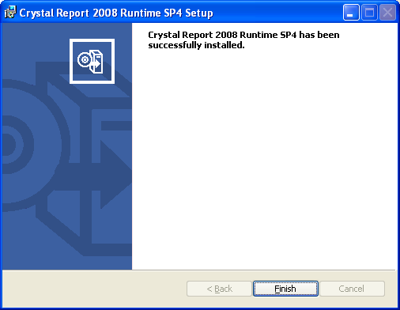

Click Finish to complete this installation.



problem?
If you experience any problems during this installation or have any questions, contact our technical support. You can find the information in Chapter 4.

Upon successful installation of the Crystal Report runtime files you are ready to proceed to the installation of Crystal Clear Essentials.

CrystalClearEssentialsInstaller.exe

!

Important:
Make sure ACT! is not running before proceeding with the Crystal Clear Essentials installation.

Download the CrystalClearEssentials2Installer.exe file to your computer.
Double-click the CrystalClearEssentials2Installer.exe to begin installation.

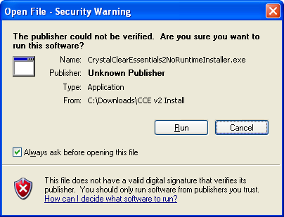

If you receive the following dialog, click the Run button.

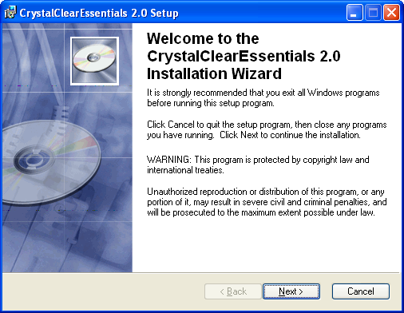

Click Next

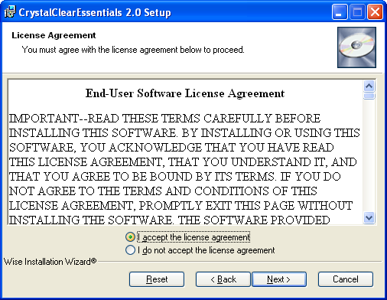

Click the “I accept the license agreement” radio button and Click Next

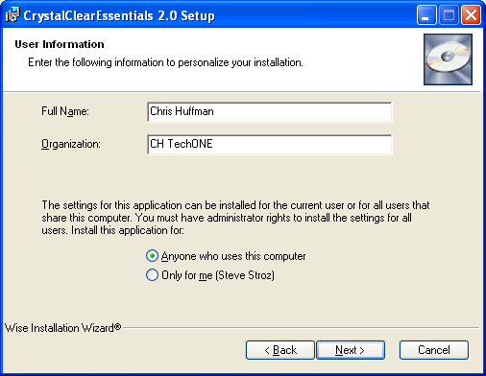

Fill out the Full Name and Organization boxes and click Next

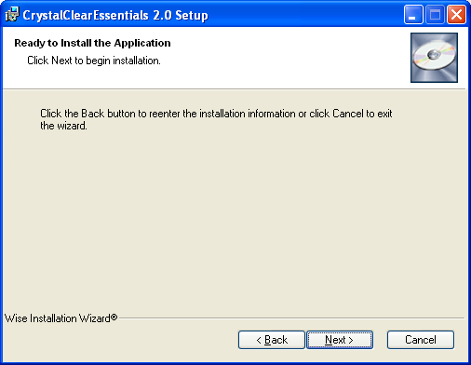

Click Next

The installer will begin to copy and register files on your computer. This process will take a few minutes.

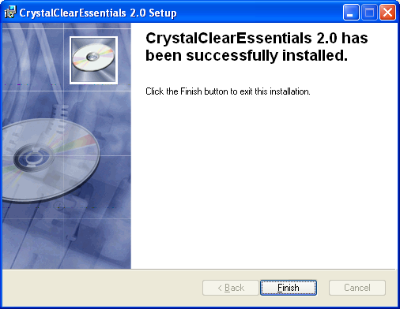

Click Finish to complete this installation.



problem?
If you experience any problems during this installation or have any questions, contact our technical support. You can find the information in Chapter 4.

File Locations

Crystal Clear Essentials System Files:
The Crystal Clear Essential system files are located in the Plugins folder under the ACT for Windows folder. For example:
C:\Program Files\ACT\ACT for Windows\Plugins

The names of the files are:
- CrystalClearEssentials.dll
- Interop.ADODB.dll
- Interop.ADOX.dll

Crystal Report Files:
The 61 Crystal Clear Essentials report files are located under a CCE2 folder in the Plugins folder. For example:
C:\Program Files\ACT\ACT for Windows\Plugins\CCE2

Adding Custom Crystal Report Files:
Your custom Crystal Report files can be added to Crystal Clear Essentials by adding them to the CCE2 folder. Once ACT! is restarted the report files will be added and available.

The Crystal Clear Essentials Auto-update Report Location:
The Crystal Clear Essentials auto-update report location is contained in the following file:
C:\Program Files\ACT\ACT for Windows\Plugins\CCE2\
CCEReportsDownloadLocation.txt



Tip:
You can redirect the Crystal Clear Essentials auto-update report location to a private website or network location! This feature allows you to add custom reports and provide version control for a multi-user deployment!

The Crystal Clear Essentials Auto-update Report File List:
The Crystal Clear Essentials auto-update report file list is contained in the following file:
C:\Program Files\ACT\ACT for Windows\Plugins\CCE2\
CCEReports.txt

These files can be easily modified using notepad to add or remove additional reports developed by your ACT! certified consultant or the Crystal Clear Essentials staff. If you modify the file, make sure to save the file (File, Save) and restart ACT! to see your changes.

Purchase & Registration
You must purchase and register a copy of Crystal Clear Essentials for every computer where you intend to run Crystal Clear Essentials reports.

The 61 Crystal Clear Essentials version 2 reports are protected and will not work on computers without a copy of Crystal Clear Essentials version 2.

Trial Mode

You can try Crystal Clear Essentials free for 14 days. Every time you run a report you will see the following dialog:

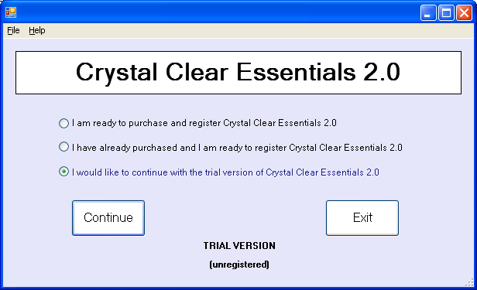

To continue trying Crystal Clear Essentials, Select the “I would like to continue with the trial version of Crystal Clear Essentials 2.0” radio button and Click the Continue button.

Purchasing and Registration

To purchase Crystal Clear Essentials:

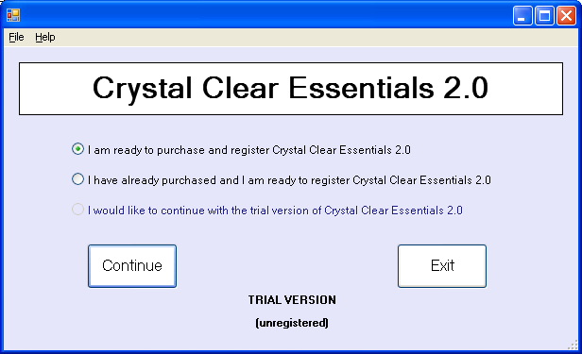

Click the “I am ready to purchase and register Crystal Clear Essentials 2.0” radio button and click the Continue button.

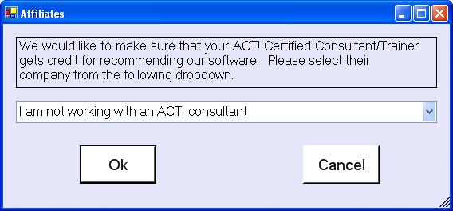

If you are working with an ACT! certified consultant click the drop down arrow to select the name of their organization. Click the OK button.

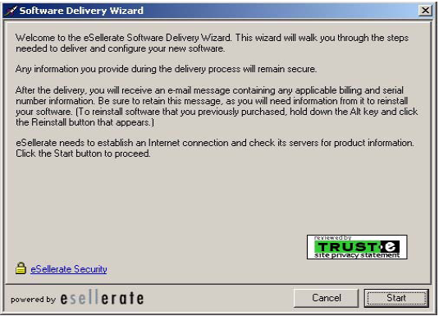

Click Start

About esellerate

Your privacy and security are a top priority at Crystal Clear Essentials which is why we have selected one of the premier leaders in Internet security to handle our purchase and registration procedures.

Esellerate utilizes the strongest exportable encryption available, licensed from Certicom—a leading provider of mobile e-business security technology used to build strong, fast, and efficient security solutions. All information transferred to and from the client is encrypted. Information stored on our servers, including your software downloads, is always stored in an encrypted form.

Payment Services
All payment processing is handled by Esellerate’s world-class partners, VeriSign and CyberSource, providing the leading Internet payment systems available. The average transaction takes less than three seconds.

Oracle™ Database Solution
All inter-server communication is encrypted to prevent packet-sniffing devices from reading any information transmitted across our networks. Esellerate’s data centers are also fully protected behind an advanced system of firewalls and network security software.
No Storage of Credit Card Numbers
For customer protection, eSellerate does not store complete credit card numbers after the transaction.

Maximum Download Protection
Be assured that all of your download files are kept in encrypted format behind firewalls. In addition, we secure your downloads with one of the strongest encryption technologies ever designed: Certicom's Elliptic Curve Cryptography (ECC).

24/7 Network Monitoring
Esellerate’s Data Centers are monitored 24 hours a day, seven days a week to protect against hacking, fraud, theft, and denial of service attacks. Esellerate’s servers are continuously monitored by their internal staff, as well as the experts at their Internet backbone providers and 3rd-party monitoring services.

LEARN MORE ABOUT ESELLERATE
To learn more about eSellerate, you may contact them at 888-477-3269 or visit them at www.esellerate.net.

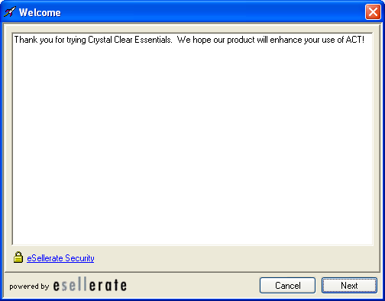

Click Next

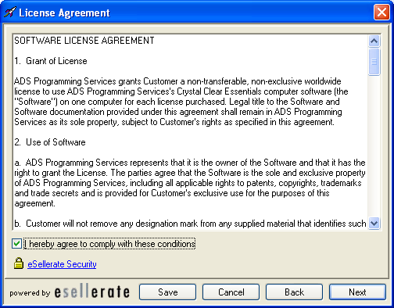

You can click the Save button to keep a copy of the license agreement.
Click in the “I hereby agree to comply with these conditions” check box and click Next

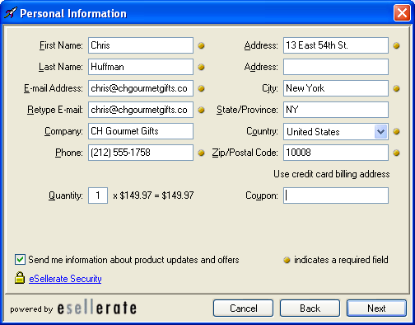

Complete the fields with appropriate information. Make sure to complete required fields. Click Next
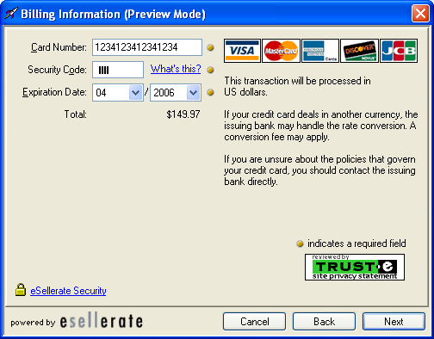

Enter your Credit Card Number, Security Code, and Expiration Date.

Click Next

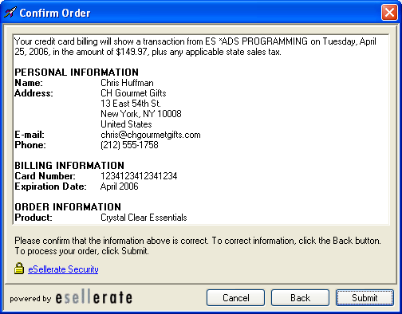

Click Submit to confirm your order

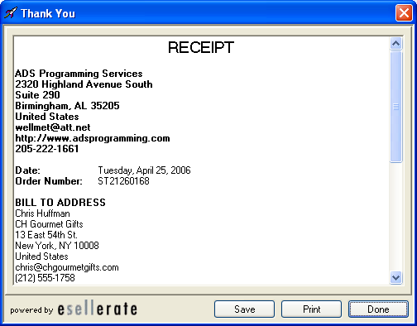

After your order is processed you can click the Save button to save your receipt or click the Print button to send a copy to your printer.

Click Done to complete the purchase and registration process.

If you already have a serial number

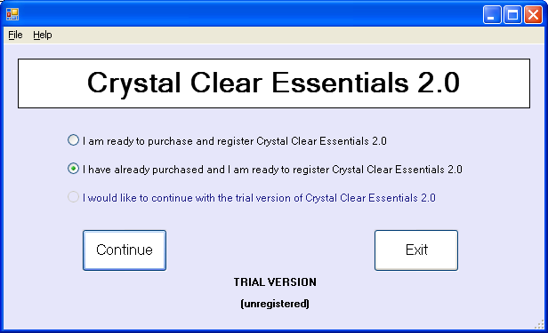
Click the “I have already purchased and I am ready to register Crystal Clear Essentials 2.0” radio button and click the Continue button

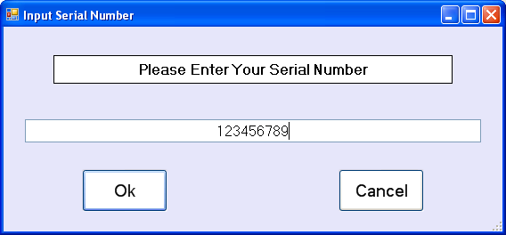

Enter your serial number and click the OK button

Uninstalling Crystal Clear Essentials

To uninstall the Crystal Clear Essentials program from your workstation click Start -> Control Panel -> Add or Remove Programs.

Highlight the CrystalClearEssentials 2.0 Program and click the Remove button.

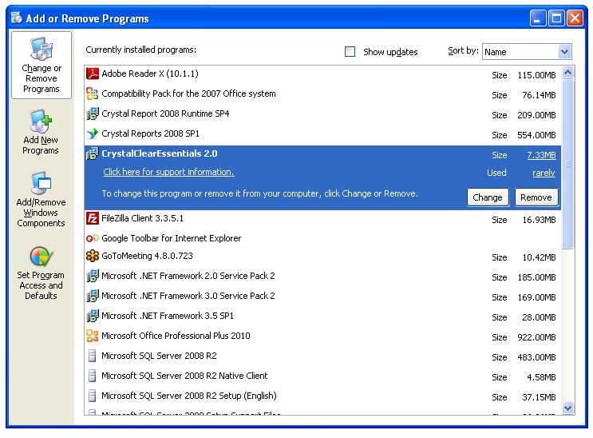
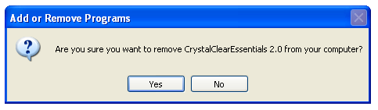

Click Yes

After Windows completes the removal procedure you can close the Add or Remove Programs window.

Chapter
2
Crystal Clear Essentials Basics
How to use Crystal Clear Essentials.
I
n this chapter we discuss how to enter user prompt values, run, print, and export reports using Crystal Clear Essentials.

Running Reports
Open ACT! and click the Reports menu item. Click on the Crystal Clear Essentials 2.0 menu item to launch the Crystal Clear Essentials 2.0 command center.

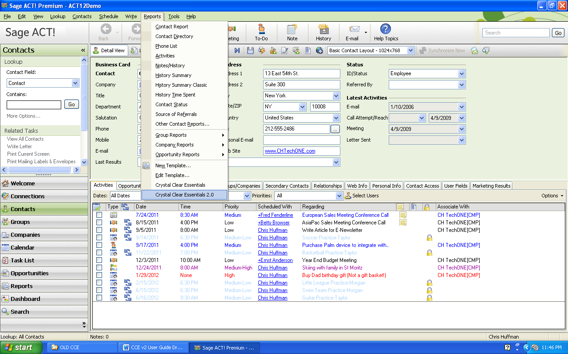

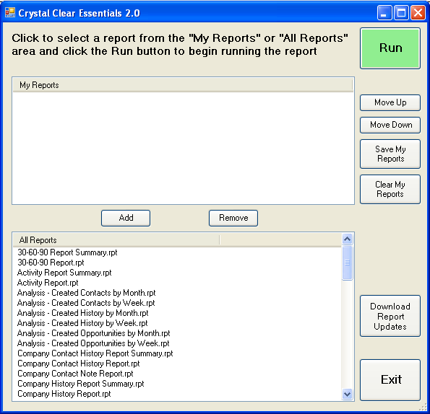

To begin running a report, click to select a report from the “My Reports” or “All Reports” window and click the green Run button.

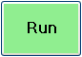

If this is the first time you are running a report during this ACT! session you will be asked to log-in to your database as a security precaution. If you have a database password, enter it and click the Ok button. (Crystal Clear Essentials will remember your log-in and password for the remainder of this ACT! session).

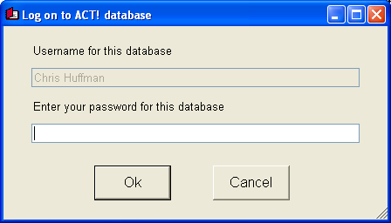
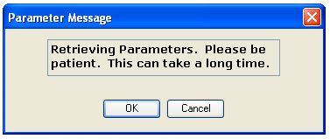

The message above will be displayed as Crystal Clear Essentials is accessing your ACT! data and preparing the “parameter” data. You can wait or click the OK button.

The Enter Parameter Values window appears:

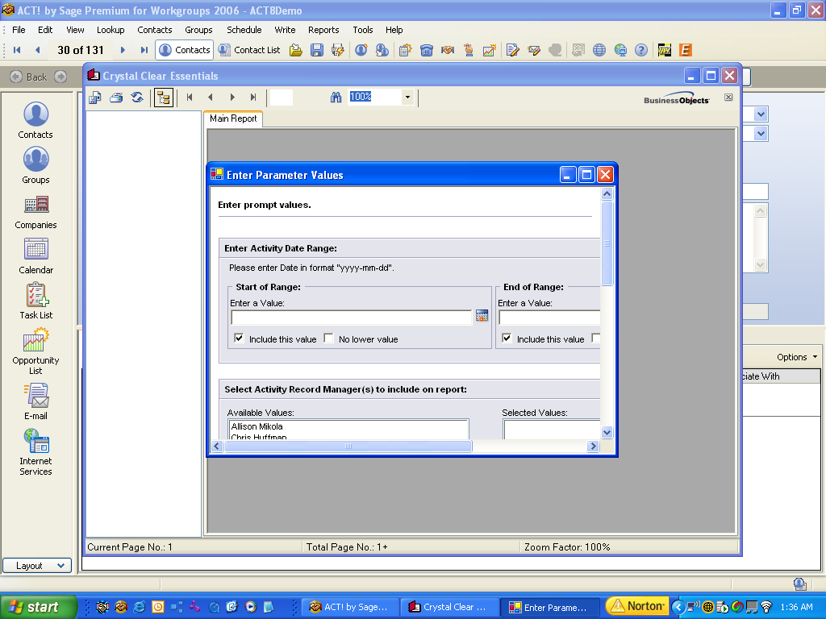

After the report initializes you will see the Enter Parameter Values screen. Fill in each parameter (user prompt) to match the desired report outcome. Click the OK button to generate the report.

After the report runs it will be visible in the Crystal Clear Essentials window.



Tip:
You can maximize the Enter Parameter Values dialog by pressing the window control. This makes it easier to enter the parameters.

Working With Parameters (User Prompts)
Parameter fields or “user prompts” are used to make a report more flexible. For instance, by prompting the user running a report to enter a Date Range, the user can determine if the report will display information for last year, last month, last week, yesterday, etc. By adding a Record Manager prompt, users can run a report for one, some, or all of the ACT! system users.

Most Crystal Clear Essentials user prompts are Dynamic, meaning that the report reads your ACT! data first to build a list of appropriate choices.

Here is an explanation of some of the common Crystal Clear Essentials parameters:

Filter (All Contacts/Current Lookup)
Allows the user to run the report for “All Contacts” in their ACT! database or a “Current Lookup” of records pre-selected by the user.

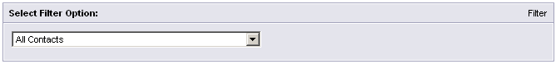

Date Range
Narrows the report to items that fall within the user’s specified date range.
(Activity Occur Time, History Start Date, Note Date, Opportunity Actual Close Date, or Opportunity Estimated Close Date)

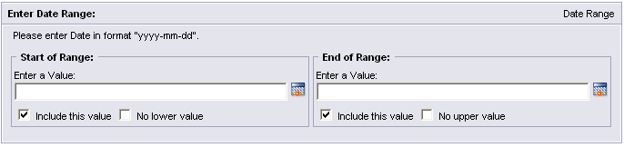
Enter a start and end date. You can type in a value as long as it meets the Year-Month-Day format (2006-05-11). You can also click the calendar icon next to the “Enter a Value:” box and select a date from the calendar dialog box.

Record Manager
Used to determine which users information will be included in the report. This list is built by reading the ACT! data. It only includes Record Managers that actually have data. *Note, this may differ from the user list. If you have an ACT! system user called: John Doe, but John doesn’t have any matching records – he won’t be included in the list.
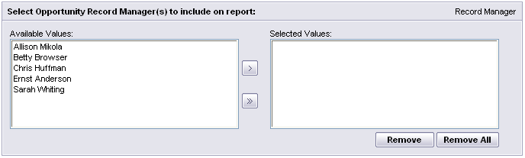
Click on a Record Manager to highlight them. Use the single arrow button to move them to the “Selected Values:” box. You can use the double arrow to easily add all of the users to the “Selected Values:” box. Lastly you can use the Remove or Remove All button to undo your selections.

Report Display
Used to select “Summary & Details” or “Summary Only”.

Activity Type
Used in activity reports. Determines which activities will be included in the report. This list is built automatically by reading the ACT! data and will include custom activity types you have added to your ACT! system.

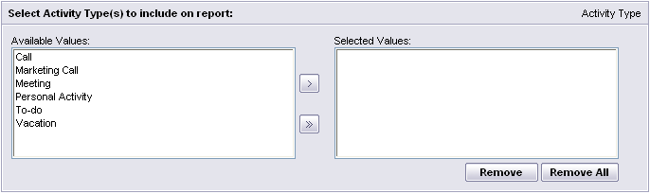
Click on an activity type to highlight the value. Use the single arrow button to move them to the “Selected Values:” box. You can use the double arrow to easily add all of the users to the “Selected Values:” box. Lastly you can use the Remove or Remove All button to undo your selections.

History Type
Used in history reports. Determines which history items will be included in the report. This list is built automatically by reading the ACT! data and will include custom history types you have added to your ACT! system.

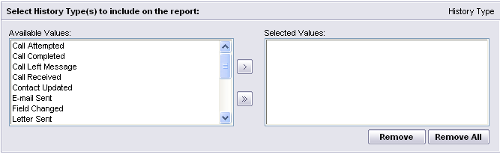

Click on an history type to highlight the value. Use the single arrow button to move them to the “Selected Values:” box. You can use the double arrow to easily add all of the users to the “Selected Values:” box. Lastly you can use the Remove or Remove All button to undo your selections.

Group Name
Used in the Group History Report. Determines which groups will be included in the report. This list is built automatically by reading the ACT! data and will include groups that you have added to your ACT! system.

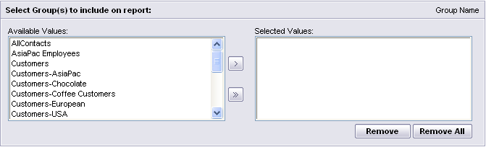

Click on a group name to highlight the value. Use the single arrow button to move them to the “Selected Values:” box. You can use the double arrow to easily add all of the users to the “Selected Values:” box. Lastly you can use the Remove or Remove All button to undo your selections.

Opportunity Range
Used in the 30-60-90 report to include only the opportunities that fall within 90 days of the run date, or “All Open Opportunities”.

The Crystal Clear Essentials Window

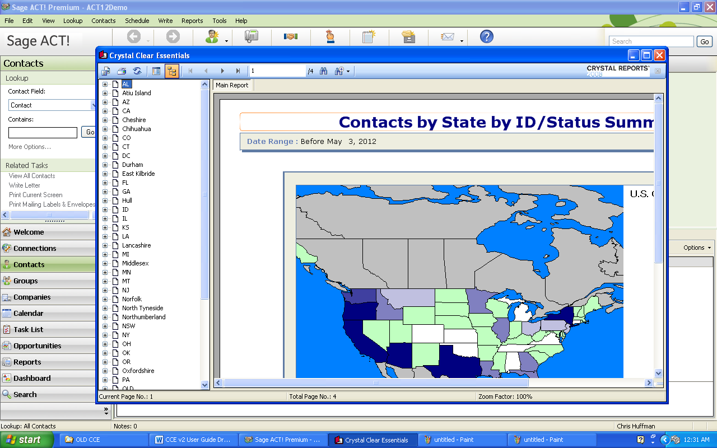

Crystal Clear Essentials Tool Bar

Icon | Function
 | Used to export the report
 | Used to print the report
 | Used to refresh the report contents
 | Used to turn on/turn off the Parameter panel
 | Used to turn on/turn off the group tree display
 | Used to navigate through the report pages
 | Displays the current page and total number of pages in a report
 | Used to find text in a report
 | Used to Zoom in or out of the report display



Tip:
You can use the button in the group tree view to expand the groups in a report. Click on an item to advance the report directly to that information.

Printing Reports
Click the button on the Crystal Clear Essentials tool bar to initiate the print process.

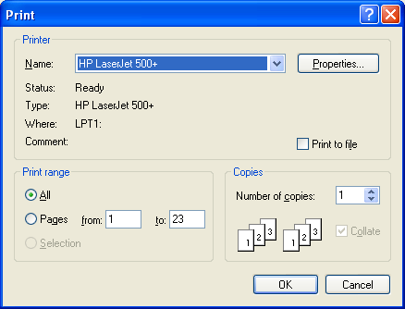

At the following dialog you can select other system printers and click the Properties button to access unique printer properties. Also, you can adjust the Print range and number of copies. To send the output to the printer, click the OK button.

Exporting Reports
Click the button on the Crystal Clear Essentials tool bar to initiate the export process.

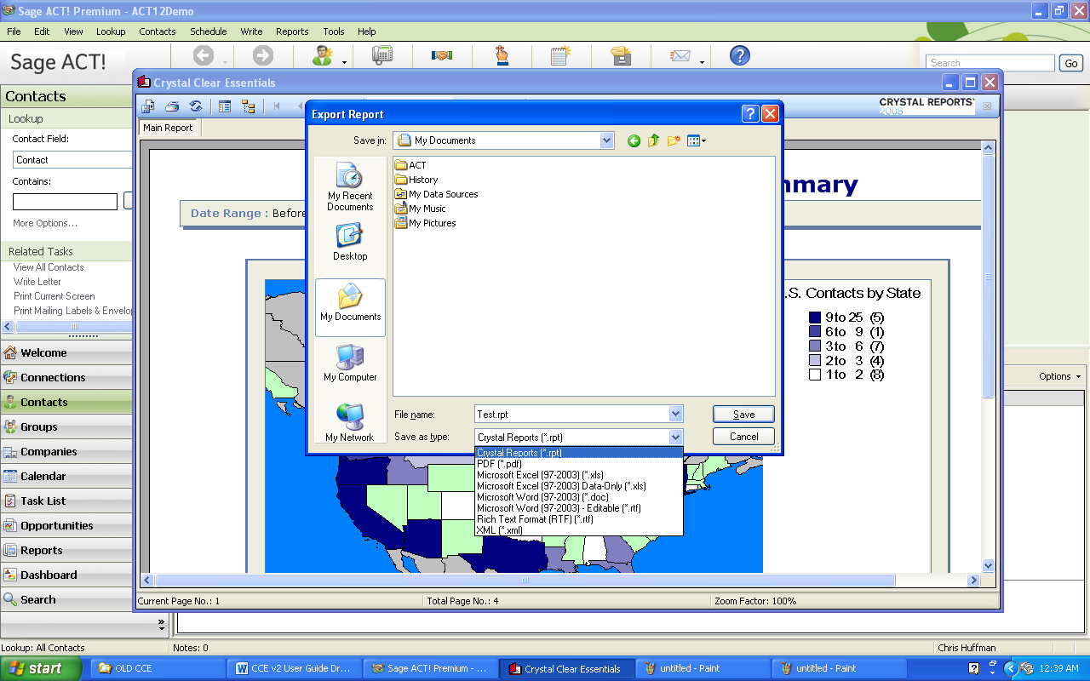

Click the down arrow in the Save as Type to select the appropriate file type.

Available file types:
- Crystal Reports (*.rpt)
- PDF (*.pdf)
- Microsoft Excel (97-2003) (*.xls)
- Microsoft Excel (97-2003) Data-Only (*.xls)
- Microsoft Word (97-2003) (*.doc)
- Microsoft Word (97-2003) – Editable (*.rtf)
- Rich Text Format (*.rtf)
- XML (*.xml)

Use the Save In: box to navigate to the folder to save the file, enter a name in the File name box and click the Save button.

My Reports Window

Crystal Clear Essentials 2.0 now includes a My Reports window so you can quickly access your favorite reports.

Adding Reports to the My Reports Window

To add a report to the My Reports Window, select the desired report from the “All Reports” window and click the Add button.

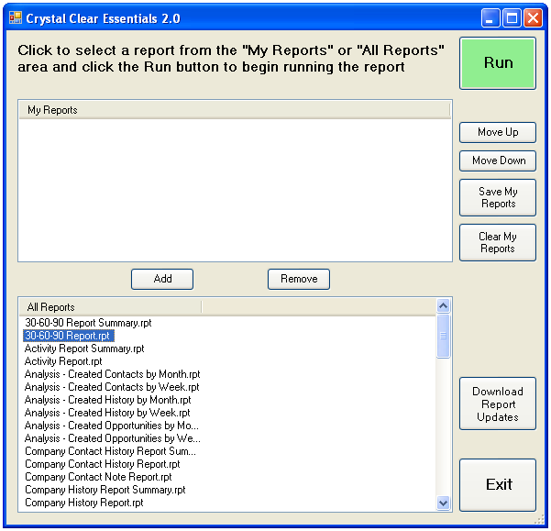

You can add several reports in this manner:

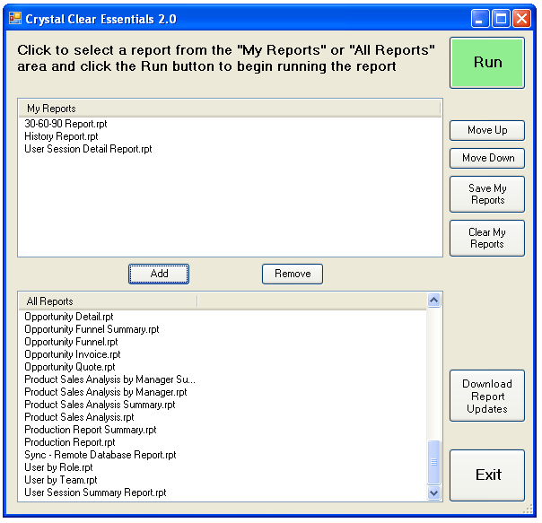

Removing Reports from the My Reports window

To remove a report from the My Reports window, click the desired report and click the Remove button.

Repositioning Reports in the My Reports window

To reposition (change the order) of the reports in the My Reports window, select a report and use the Move Up or Move Down button to move the report to the desired location. Repeat this step for other reports in the My Reports window.

Saving your changes to the My Reports window

To save your changes, click the Save My Reports button 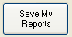. You can also use the Clear My Reports button 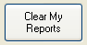 to remove all of the reports from the My Reports window.

Updating Crystal Clear Essentials

Crystal Clear Essentials 2.0 now allows you to automatically download report updates. This is a convenient way to make sure you always have the correct version of your Crystal Clear Essential reports.

To update your reports, connect your computer to the Internet and click the Download Report Updates 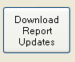 button:

The Download Files window appears:

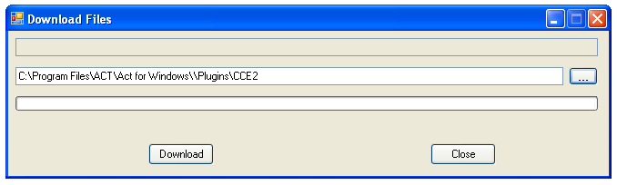

Click the Download button to proceed. (Click the Close button to cancel the report update).

Crystal Clear Essentials will begin the automatic update of the reports.

Chapter
3
Report Descriptions
An explanation of the standard Crystal Clear Essentials reports.
E
ach report category and individual reports are identified.

Contact Reports

The following reports focus on the ACT! contact entity:

- Contacts by Referred By by IDStatus
- Contacts by Referred By by IDStatus Summary
- Contacts by State by IDStatus
- Contacts by State by IDStatus Summary
- Contact Relationship Report by Contact

Company Report
The following reports focus on the ACT! company entity and related contact, history, and notes items:

- Company Contact History Report Summary
- Company Contact History Report
- Company Contact Note Report
- Company History Report Summary
- Company History Report
- Company Note Report

Group Reports
The following reports focus on the ACT! group entity and related contact, history, and notes items:

- Group Contact History Report Summary
- Group Contact History Report
- Group Contact Note Report
- Group History Report Summary
- Group History Report
- Group Membership for Contacts
- Group Note Report

Opportunity Reports
The following reports focus on the ACT! opportunity entity:

- 30-60-90 Report Summary
- 30-60-90 Report
- Competitive Analysis - Who Summary
- Competitive Analysis - Who
- Competitive Analysis - Why Summary
- Competitive Analysis - Why
- Marketing Campaign Analysis Summary
- Marketing Campaign Analysis
- Opportunity Close Ratios
- Opportunity Close Ratios Summary
- Opportunity Detail
- Opportunity Funnel Summary
- Opportunity Funnel
- Opportunity Invoice
- Opportunity Quote

Product Reports
The following reports focus on the ACT! product entity:

- Product Sales Analysis by Manager Summary
- Product Sales Analysis by Manager
- Product Sales Analysis Summary
- Product Sales Analysis

Activity Reports
The following reports focus on the ACT! activity entity:

- Activity Report Summary
- Activity Report
- Production Report Summary
- Production Report

History Reports
The following reports focus on the ACT! history entity:

- History Report Summary
- History Report
- History Summary by Contact Summary
- History Summary by Contact
- History Summary by IDStatus Summary
- History Summary by IDStatus
- History Time Spent by Company
- History Time Spent by Contact

Note Reports
The following report is focused on the ACT! note entity:

- Note Report

Analysis Reports

The following reports can be used to determine the number of new contact, history, and opportunity entries that have been added to your ACT! database (system usage):

- Analysis - Created Contacts by Month
- Analysis - Created Contacts by Week
- Analysis - Created History by Month
- Analysis - Created History by Week
- Analysis - Created Opportunities by Month
- Analysis - Created Opportunities by Week

System Reports
The following reports can be used to determine how system users are organized, who is using the system, and the status of a synchronized database:

- Sync - Remote Database Report
- User by Role
- User by Team
- User Session Detail Report
- User Session Summary Report

Chapter
4
Resources
Where to go for additional help or answers.
A
friendly staff of technicians, developers, and consultants are available to help you with your questions or problems.

Installation Trouble, Registration Problems, or Error Messages
e-mail:
Stan Smith, ADS Programming
ssmith@adsprogramming.com

Crystal Clear Essentials Report Questions
e-mail:
support@crystalclearessentials.com

Additional Report Requests
ACT! Certified Consultants
website:
http://www.act.com/Partners/Certified-Consultants

Crystal Clear Essentials Development Staff
e-mail:
requests@crystalclearessentials.com

